You Cared for Sandra
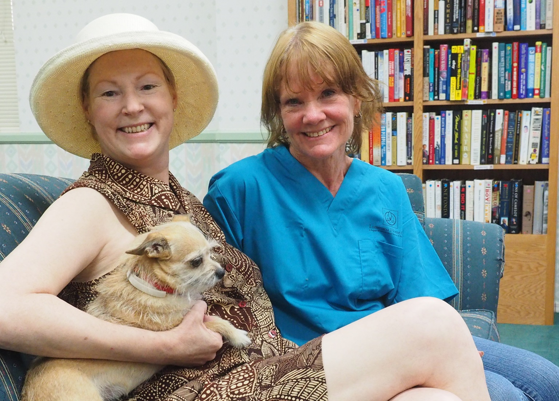
Sandra is a widow in Cottonwood who lives on less than $10,000 a year. Her life changed in 2012 after surviving a violent assault that left her physically, emotionally, and spiritually shattered. After waiting for over a year for in-home care services, on the eve of another surgery, she received a miracle phone call that she would be receiving an LSS-SW caregiver. Says Sandra - "It's a BIG deal to have a caregiver like Lana. You're on this journey all by yourself, and then you have somebody. I don't feel like less of a person anymore."
Your support insures that women like Sandra receive the in-home care they need during a time of great need. Lutheran Social Services of the Southwest is a qualifying charity for the Arizona Charitable Tax Credit – a “free” way to make a cause that you care about. Receive a dollar-for-dollar credit on your state taxes of up to $800 for couples filing jointly or $400 for individuals.
Visit lss-sw.org/donate for more information.
