You Called Nura Out of Darkness
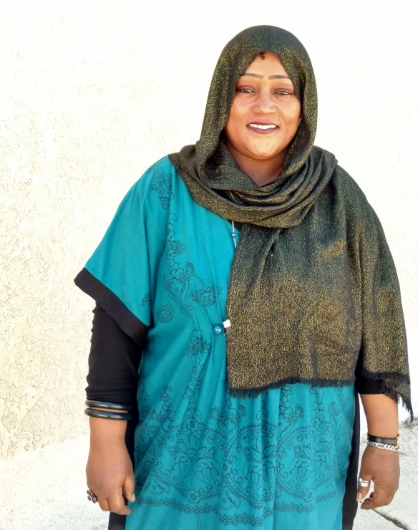
Nura wakes up most nights crying in her sleep.
Maybe she is haunted by the memories of 20 years in a refugee camp – not knowing when reprieve would come. Maybe her spirit forgets that her abusive ex-husband is on the other side of the world – no longer able to beat and threaten her. Maybe she feels the weight of being a single mom of three children in a new country – having never had the chance to earn a living before.
But during the day – Nura is a different woman.
She works stocking shelves at a local store and learns the independence that comes with a hard earned paycheck. She makes friends with her co-workers. She studies English so that she can pursue her GED and advance her job opportunities. She focuses on her wellness with nutritious meals and exercise, with goals of improving her chronic illnesses that were never treated in the camp.
Nura is just one of hundreds of refugees that arrived in Arizona in 2016 because of your support. With simple tools like nutrition classes, English classes, and a routine medical appointment – Nura has began to blossom. Nura’s next goal is to study for her driver’s permit, so that she has more reliable transportation to work.
There are many refugees like Nura that are already in Arizona and need your support so that they can continue to access our services during a delay in resettlement funding. Your gift on Arizona Gives Day makes this work possible. Thank you.
To learn more about Lutheran Social Services of the Southwest, visit them online at www.lss-sw.org.
