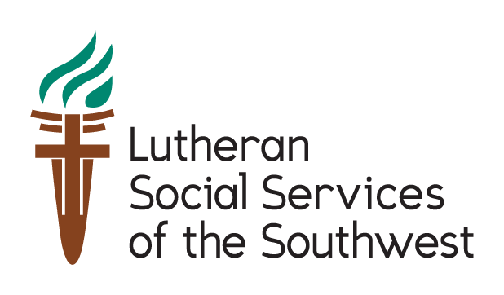
Creating a Community Where Everyone Has a Home
As Lutherans, our faith calls us to care for those in need and welcome the stranger. As a nation that has proudly stood as a beacon of hope for those in need, we are defined by our commitment to compassion for the vulnerable and justice for all.
Every year, Lutheran Social Services of the Southwest re-settles 1,000 refugee families in Arizona. About 80% are women and children, and each refugee undergoes extensive interviewing, screening, and security clearance process. We rely on our congregational communities for support.
You can make a difference to our refugee families
- Co-sponsor an arriving family
- Donate furniture, personal hygiene items, or an automobile
- Volunteer in areas such as interpretation, teaching, and childcare
- Make a gift to Lutheran Social Services to the Southwest
Contact Rev. Deborah Hutterer to get started, at dhutterer@lss-sw.org, or 480-396-3795 ext. 102.
Connect with Lutheran Social Services of the Southwest:
lss-sw.org/subscribe
facebook.com/lsssw
twitter.com/lssofsouthwest

Creating a Community that Welcomes the Stranger

Arizona has always been proud of our multi-cultural heritage. The blending of Native American, Latino, and Western heritage has become something uniquely Southwest. It draws people here, making Arizona home to people from colder climates. It is a vibrant, engaging state that has benefited from new neighbors.
Over the past few years, events across the globe have brought a different set of neighbors, people who have come not in search of our sun, but in search of safety. They are fleeing war and persecution. And they bring new cultures and a different faith.
As we have watched the world's events, there have been many voices competing for our attention. The voices of people of the Islam faith have often been drowned out, making it difficult for us to learn about their practices. Without information, we rely on what we think we know, or may have heard, and that can lead to us seeing these new neighbors as "other," people not like us.

June 20 marks World Refugee Day, an international observance dedicated to raising awareness of refugees throughout the world. Here are 4 ways you can celebrate this day with us:
- Host a "My Neighbor is a Muslim" study group using this guide created by Lutheran Social Services of Minnesota.
- Use these various pieces of litany authored by Pastor Steve Holmes, retired and Pastor Alan Field of New Spirit Lutheran Church, Tucson.
- Sponsor a newly arrived refugee family as a congregation. You will do things like prepare their apartment for arrival, greet them at the airport, and support their unique needs as they adapt to the community. Contact Rev. Donna Buckles to get started.
- Share messages of welcome on social media in honor of World Refugee Day - samples can be found on our website.
Conversations are truly the key. Over the past few months I have been touched by the number of people who have reached out to us to find out how they could help. The pictures and stories of refugees are touching the hearts of many who feel compelled to act.
We are hopeful that this these tools will spark an important dialogue about our role in welcoming the stranger and creating strong communities. We will all benefit.

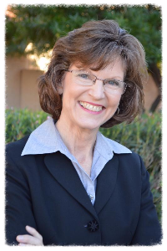
Connie Phillips, MSW
President/CEO
Lutheran Social Services of the Southwest

