Petrit’s New Beginning
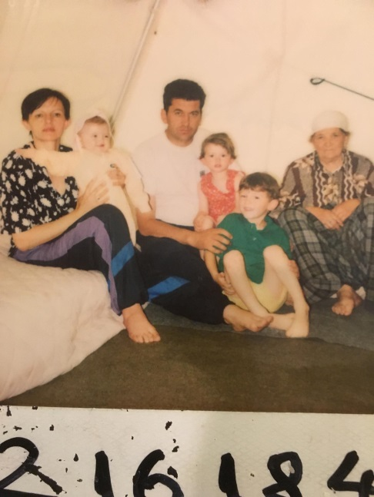
Petrit (front, in green shirt) was born in Pristina, Kosovo in 1995, where political strife made daily survival an uncertainty.
Between bombings and gunfire, his father was arrested and held for a time. One night his beloved grandfather was taken and never seen again. It was 1999 and authorities had begun a campaign of ethnic cleansing of Kosovo Albanians. His family - mother, father, two younger sisters and his grandmother - were desperate to escape.
“We had to leave,” Petrit recalls. “Everything was burned. There were bullet holes in the doors. We had to keep moving from place to place to find somewhere we could be safe.”
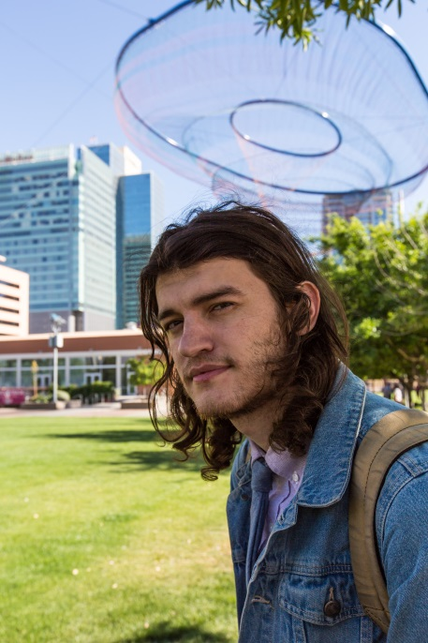
After many months, including time living in refugee camp tents, the family secured passage to the United States with the help of LSS-SW. Because of your generosity, the family was able to secure housing, jobs, training, English and computer classes.
Today, Petrit’s parents work in real estate and banking, his sisters study at local schools and he is tackling a master’s degree in social justice and human rights at Arizona State University.
“LSS-SW gave us a stepping stone that helped us stabilize and start living again. There have been challenges. But there were so many people to help us. But we never took things for granted. We have all worked to become a part of the fabric of what it means to be an American."
To learn more about Lutheran Social Services of the Southwest, visit www.lss-sw.org. Contact <NAME> to find out more about how <Church> needs you in their ministry partnership.
