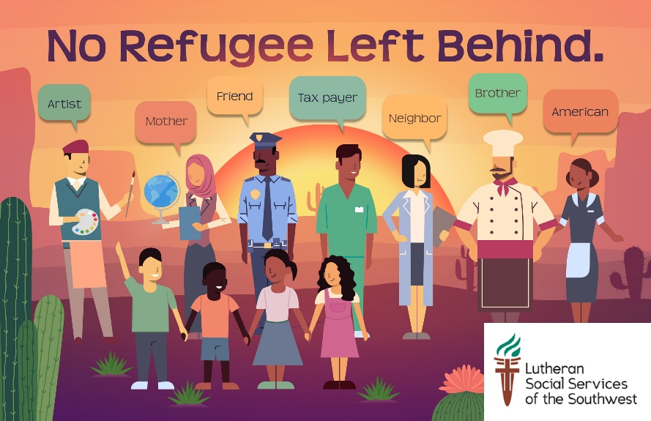

MESSAGE STARTERS
FAITH MESSAGE
My faith has taught me to welcome the stranger, stand with the vulnerable, and love my neighbor. It is because of those values that I am disturbed by our Administration’s recent anti-refugee sentiment. I’m asking you to show mercy and hospitality to those fleeing persecution by urging the President to welcome the 30,000 refugees he agreed to admit in 2019.

SCRIPTURES YOU CAN INCLUDE, OR WRITE INSTEAD OF A MESSAGE
From the Quran we read: “And (as for) those who believed and fled and struggled hard in Allah's way, and those who gave shelter and helped, these are the believers truly; they shall have forgiveness and honorable provision.” (Quran 8:74 )
From the Torah we read: “Love your neighbor as yourself” (Lev. 19:18)
From the Bible we read: “And you are to love those who are foreigners, for you yourselves were foreigners in Egypt.” (Deuteronomy 10:19)]

“OUR AMERICAN HERITAGE” MESSAGE
As Americans, we live in a country built in part by the hard work, dreams, and determination of generations of immigrants and refugees. Sadly, it seems that our legislators have forgotten these lessons and have acted with fear instead of compassion. Today, I am asking you to remember our American heritage and hold the Administration accountable by resettling 30,000 refugees.

“REFUGEE ARE LIKE US” MESSAGE
Refugees are mothers, fathers, and children. They are doctors, teachers, lawyers, business owners…etc. These people are no different than us; they are just looking for a chance to rebuild their lives and create a better future for their families. Today, I am asking you to show the same welcome we would hope for ourselves, and urge the President to welcome 30,000 refugees in 2019.

“WE HAVE AN OBLIGATION” MESSAGE
We are facing the world’s worst refugee crisis in recorded history with over 25 million refugees, over half of whom are children. I believe that we have a moral and legal obligation to welcome refugees into the U.S. Please hold the President accountable by resettling at least 30,000 refugees in 2019.

“REFUGEE CONTRIBUTE TO SOCIETY” MESSAGE
Refugees revitalize cities and rural communities across the U.S. They fill empty jobs, become entrepreneurs and invest in businesses that offer everyday goods and services. They are important to our economy and our rich culture as an American “melting pot.” Please urge the President to welcome the 30,000 refugees he agreed to admit in 2019.

IF YOU ARE A REFUGEE YOURSELF
I came to the United States as a refugee from [COUNTRY] in [YEAR]. My family and I were forced to leave everything behind. As I reflect on my journey, I’m grateful to the U.S. for giving me another chance. I understand the struggles of refugees firsthand, and I’m disheartened to see this country is now denying that same opportunity to others. I am asking you to remain the beacon of hope you once were. Urge the President to welcome the 30,000 refugees he agreed to admit in 2019!

