Find an email message you’ve sent or have somewhere in your inbox, that has your automated email signature in it. Use your mouse to highlight it, and copy it (Ctrl + c on your keyboard copies it, or a right-click with your mouse, and choosing “copy” from the drop down choices)
Jane Smith| Director of Family Services
Lutheran Social Services of the Southwest
6303 E. Tanque Verde Road, Suite 101, Tucson, AZ 85715
cell: 480-555-1234 | office: 480-396-3795 ext. 1111
jsmith@lss-sw.org| http://www.lss-sw.org
This message is confidential. It may also be privileged or otherwise protected by work product immunity or
other legal rules. If you have received it by mistake, please let us know by e-mail reply and delete it from your
system; you may not copy this message or disclose its contents to anyone. Please send us by fax any message
containing deadlines as incoming e-mails are not screened for response deadlines. The integrity and security of
this message cannot be guaranteed on the Internet.

In Outlook, click on “File”, then “Options”
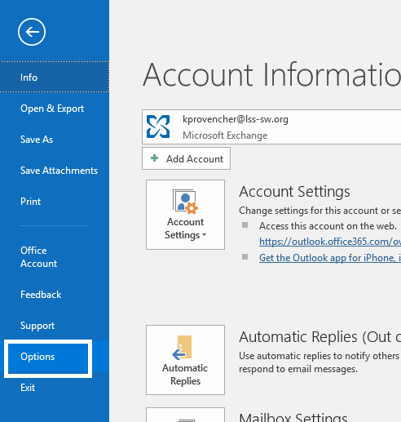
Click on “Mail”, then “Signatures”
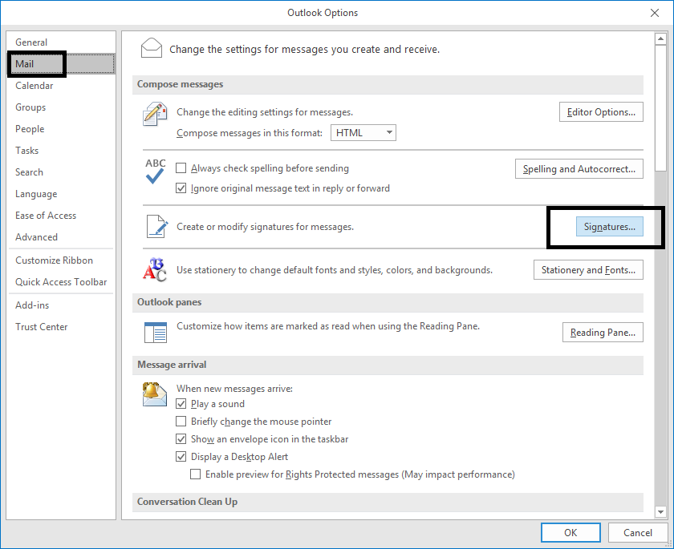
Click on “New” to create a signature, calling it whatever you want, when prompted
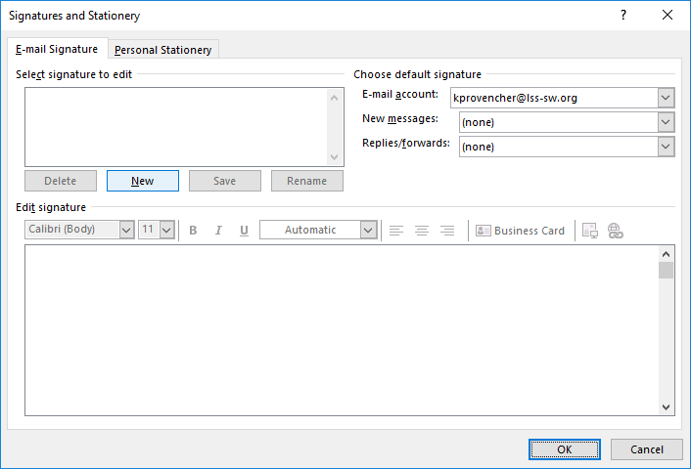
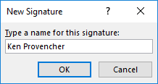
Then paste your signature into the body of the signature, as stated below
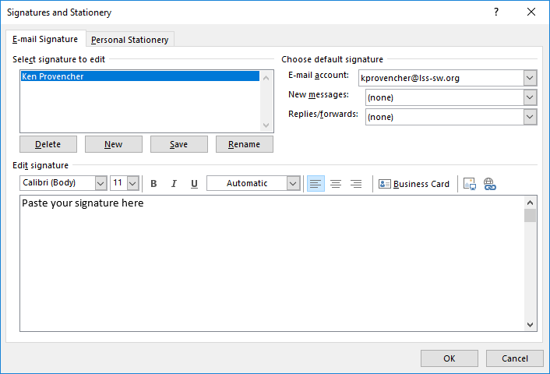
Set your signature for “New messages” and/or “Replies/forwards” in the drop-down fields above, and click on “OK”, and you’re done.
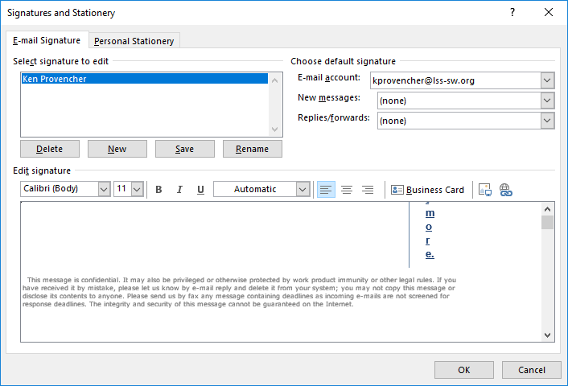
It might not look aligned after being pasted, but you can test it by starting to compose an email, and I believe you’ll see it looks good there.

