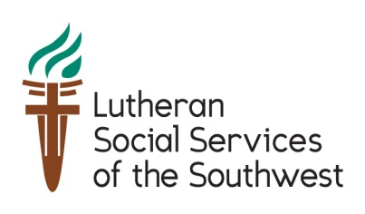
[Date]
President Donald Trump
The White House
1600 Pennsylvania Ave. NW
Washington, DC 20500
Dear President Trump and Secretary of State Tillerson:
Welcoming refugees shines a light on Americans’ most cherished common values. As a community, we believe in the strength of the U.S. refugee resettlement program and welcome refugees from all backgrounds, faiths, and countries of origin. This commitment reflects a core American belief in the dignity of every person, lifts up diversity as a community’s strength, and cultivates an environment of inclusion. Resettlement is a strong American legacy that extends hospitality and offers a chance for refugees to rebuild their lives in safety and dignity. Every day, more community members than ever before are volunteering with resettlement offices around the country to help refugees integrate and thrive.
Refugee resettlement is the living embodiment of the religious commitment to “welcome the stranger,” a bedrock upon which much of America’s strength rests. In our community, churches, synagogues, mosques, and other communities of faith stand in partnership to help refugees of all faiths find safety and hope as they start their lives as new Americans. The United States has a long history of providing protection to persons seeking safety from persecution. In Arizona, we have welcomed refugees from across the globe.
Refugees are forced to flee their homes because they face persecution on account of their religion, ethnicity, nationality, political opinion, or membership in a particular social group. Over 65 million people are displaced globally, the largest displacement crisis in recorded history, including over 21 million refugees. Resettlement offers a chance for less than 1% of the world’s refugees to reach safety in a third country when no other options remain. Resettlement to the United States is available only for those who demonstrate the greatest and most immediate need for protection and takes place after eligible refugees undergo rigorous selection, security vetting and medical screening processes.
The resettlement program is a prime example of a public/private partnership between the federal government, the state government, and local communities and their agencies and volunteers. Lutheran Social Services of the Southwest helps refugees who have been resettled in Arizona by providing them with the tools of self-reliance: housing, job placement and employment skills, English-language classes, and community orientation. Refugees are resilient, hard workers whose innovative skills have contributed greatly to our state.
Please stand with our community as we welcome refugees. I urge you to accept at least 75,000 refugees in the fiscal year 2018. Thank you for your public service, and please contact me if you have any questions about refugee resettlement in our area.
With appreciation,

