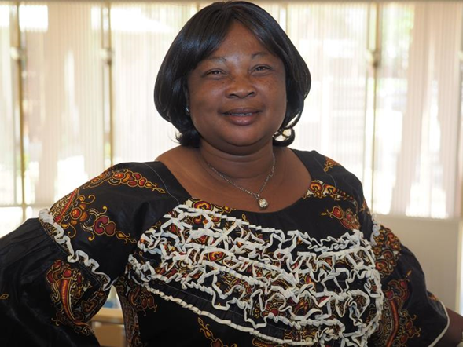

"DO NOT COME HOME. IT ISN'T SAFE HERE. I'LL MEET YOU ACROSS THE BORDER IF I AM NOT KILLED."
Can you imagine sending a note to your loved one warning them it wasn't safe to come home?
This is exactly the circumstance that Jeanette, a former refugee from the Democratic Republic of the Congo (DRC) faced multiple times in her flee from safety.
She remembers the time soldiers gave her two days to turn over her husband, solely on the basis of his ethnic group, before they returned to kill her. She remembers telling her children "This is the end," not possibly imagining that they would survive the bloodshed that surrounded them. She remembers later living in a refugee camp, longing to return home, because she was persecuted so horribly in the camp.
Decades later, in 2014, Jeanette, her husband, and children miraculously made it to Arizona. Because of your support, Jeanette and her family received case management, English class, and support they needed in establishing their life in Arizona.
Today, Jeanette is a caregiver and interpreter. She has four children in college, and is excited about their future. She aspires to be a leader in her community, and bring good to the world around her.
She recently graduated from our Women's Empowerment Leadership training, where she urged fellow refugee women:
"Take courage. Do not give up. As women, we are very special. We are strong."
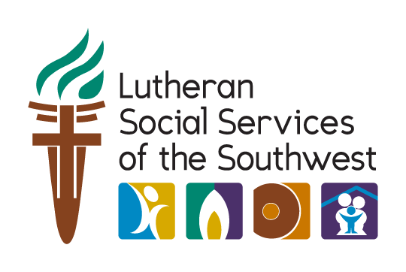
Thank you for championing women like Jeanette. To find more ways to get involved, visit Lutheran Social Services of the Southwest at www.lss-sw.org

