You Shower Michael in Dignity
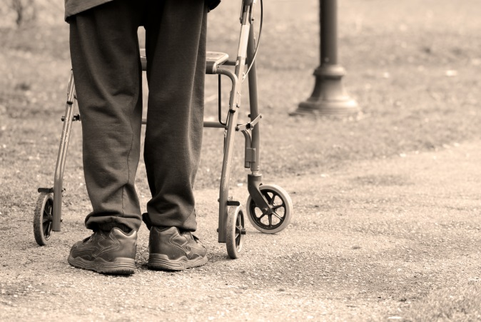
Michael, 77, is a war veteran who has struggled for many decades with an illness that makes it difficult for him to bathe himself, for fear of falling in his modest trailer.
When Michael first found LSS Luminaria Home Care, it had been many months since he had showered, and he was deeply ashamed.
Because of you, we were able to send a caregiver right away, who gave him the care (including a shower) that was badly needed.
Tears flowed from Michael’s eyes from the simple act of care. You preserved Michael’s dignity and respect.
Veterans like Michael are proud to have sacrificed for our country. You honor that sacrifice by providing basic kindness and care in the comfort of their homes. Thank you.
To learn more about Lutheran Social Services of the Southwest, visit them online at www.lss-sw.org.
