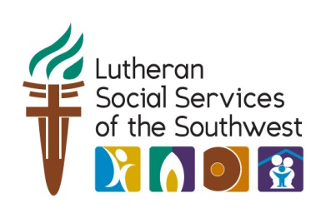

Find our page at **azgives.org/(campaginname)** on April 4

Arizona Gives Day is a single statewide day of giving that has raised $7.4 million for Arizona nonprofits since 2013.

**Invest in refugees. Invest in your community.**