Love to spare
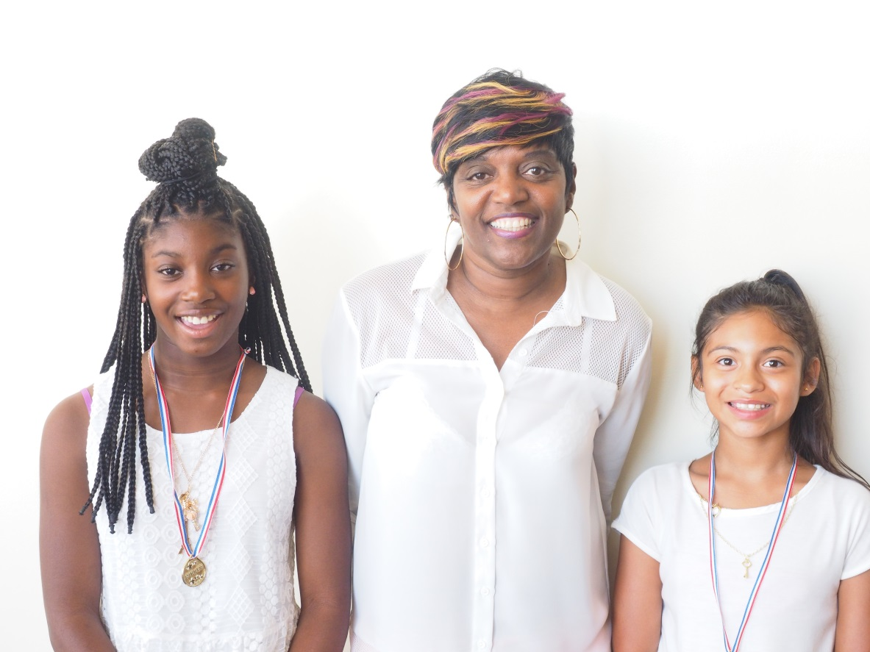

YOUR GENEROUS SUPPORT HAS STABILIZED THE LIVES OF 70 CHILDREN, INCLUDING BROOKLYN AND SELINA, THIS YEAR. THANK YOU.
"Although foster parenting is difficult, you really only need 3 things: time to give, a safe home, and a heart" says Rodina Bailey, an LSS Family HOMES foster parent.
After raising 3 adult children and building a successful career, foster parenting wasn't in Rodina's plan. But when her brother could no longer care for his daughter, Brooklyn, she opened her home without question.
It was Brooklyn who last year prompted Rodina to foster an additional child, so she could have a sibling. They were soon fostering Selina, an 8-year-old girl who had been running away from her home with extended family to escape an abusive environment.
Selina no longer runs away from home - but happily enjoys the love she is surrounded by. If you saw Brooklyn and Selina at their adoption day this July, you would see that this family belongs together.
"Brooklyn and Selina didn't ask for the life they were born into. But they have been a blessing to me," says Rodina.
She continues, "Foster parenting isn't about how much you can financially provide for a child. It's about showing them that they are loved."
FOSTER FAMILIES NEEDED
There are thousands of children waiting for safe foster homes in Arizona. Contact Caren at 1-844-891-2168 to get more information about becoming a foster parent, or consider hosting an informational session at your church.
By Lutheran Social Services of the Southwest, learn more at lss-sw.org
