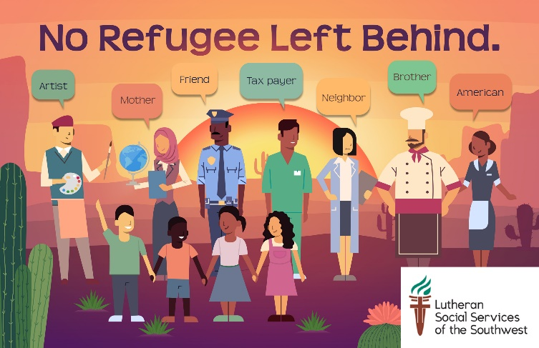

COME TO OUR POSTCARD-WRITING PARTY!
We are facing the world’s worst refugee crisis in recorded history with over 25 million refugees, over half of whom are children. In response, last year the Administration agreed to welcome 45,000 refugees to the U.S. But only 22,491 refugees were accepted in, leaving 22,491 refugees behind.
Similarly in Arizona, 2,410 refugees were projected to arrive. But only 1,392 refugees made it here, leaving 1,018 refugees behind.
In 2019 the Administration has agreed to admit 30,000 refugees. Don’t let them default on their commitment again!

HELP US SEND A TOTAL OF 1,018 POSTCARDS TO ARIZONA MEMBERS OF CONGRESS AND TELL THEM WHY REFUGEES ARE IMPORTANT TO OUR COMMUNITIES. ONE POSTCARD FOR EVERY REFUGEE WHO NEVER MADE IT TO ARIZONA LAST YEAR.
TELL THEM TO URGE THE PRESIDENT TO HONOR HIS COMMITMENT AND TRULY WELCOME 30,000 REFUGEES.

Event Location & Date:

