Remember those in need this holiday season
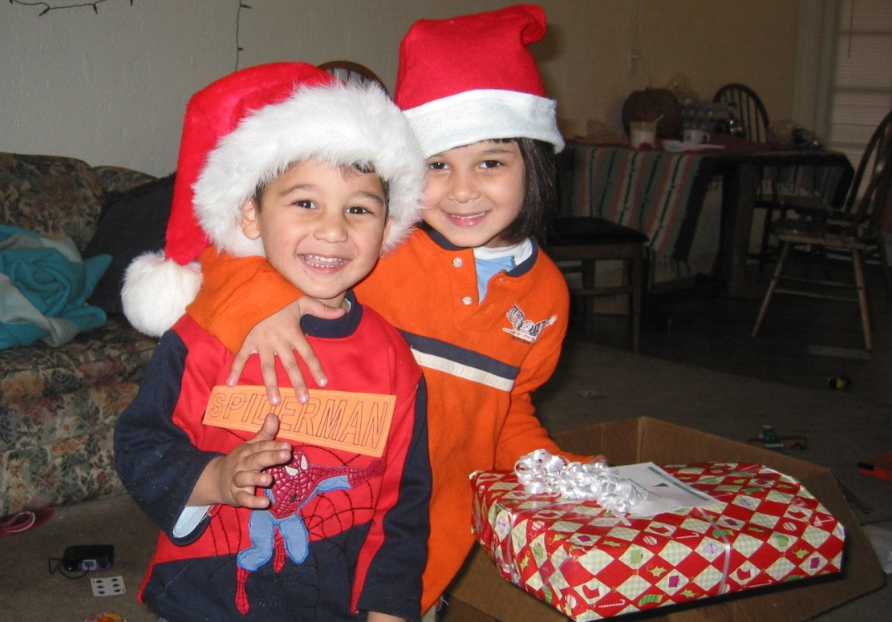

You're the kind of person that wants to make the world a better place. This holiday season, you'll be looking for gifts that inspire and amaze.
Lutheran Social Services of the Southwest is excited to unveil their holiday catalog - 10 gifts that celebrate the holidays AND make a difference to a neighbor in need.

You can give a newly arrived refugee an apartment of furniture, a woman experiencing homelessness badly needed shoes, an older adult a Hope Basket of self-care items, and more.

Order your gifts online at www.lss-sw.org/gifts and customize a special holiday card to the gift recipients. It's never been more fun or easy to have an impact with your holiday shopping.

Gifts range in price so that you can participate as a family, or as a team.

At <Congregation name>, our goal is to raise <$1,200> to <furnish an apartment for a newly arrived refugee families.>
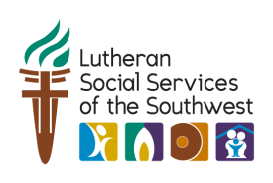
For more information, visit www.lss-sw.org/gifts.

